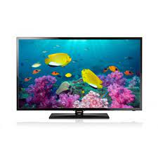

Samsung F5000

* HyperReal Engine
* Picture-In-Picture
* DTS Studio Sound
* Screen Size 40 Inch
* **Rs.48,999**